PERFORMANCE TESTING
LEASE MANAGEMENT

DATE | 1.11.2025
TEAM ID | NM2025TMID04338
PROJECT PROJECT | LEASE MANAGEMENT
MARKS | 4 MARKS

MODEL PERFORMANCE TESTING:

USER CREATION

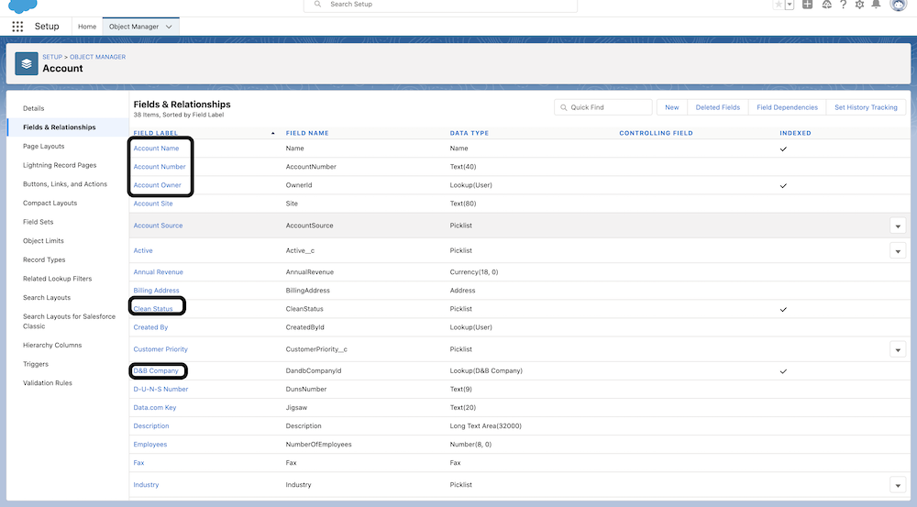

PERFORMANCE TESTING:
SI.NO | PARAMETER | Value (Description)
1. | Gather Requirements | Identify performance goals such as response time, load capacity, and system stability.
2. | Develop the Test Model | Define scenarios like number of users, transactions, and workflow paths.
3. | Select the Tools | Choose suitable performance testing tools (e.g., JMeter, LoadRunner).
4. | Design the Test Plan | Prepare detailed testing strategy including test data, schedule, and success criteria.
5. | Develop the Test Scripts | Create automated scripts for simulating user actions and workload.

